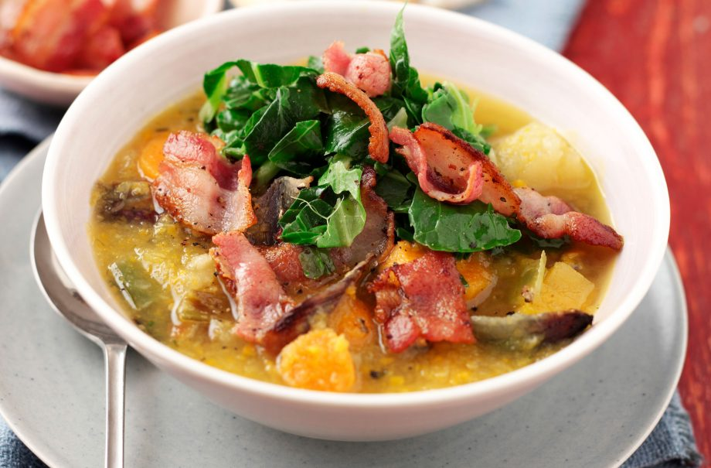jracfdwslaycrgwcrwn9

**Thank you to St Leonard’s Primary School for sharing with the St Aidan’s Community.**

## Winter vegetable soup

Asda scratch cook root veg casserole mix 1kg 99p

Asda butcher selection unsmoked streaky bacon rashers 16 £2.25

Asda loose white cabbage 90p

Asda vegetable stock cubes 12x10g 39p

Total £4.53

## Method

To start your [vegetable soup](https://www.goodtoknow.co.uk/recipes/511603/chunky-vegetable-soup) set the oven to 220°C/425°F/Gas Mark 7.

Tip the vegetables into a roasting tin and cook them for about 45 minutes until they are tender.

Chop the bacon rashers and dry-fry them until crispy. Microwave or steam the cabbage.

Pour the boiling water into the roasting tin and add the stock cubes. Use a stick blender to whizz the vegetables for a few seconds to purée some of them, but leaving some chunky bits. Stir to make sure the stock cubes have dissolved completely and season to taste.

Spoon the soup into bowls and top with cabbage and bacon.

## Ingredients

• 1kg packet frozen winter vegetable mix

• 8 rashers streaky bacon

• 100g ready-shredded cabbage

• 900ml boiling water

• 2 ham or vegetable stock cubes

• Salt and freshly ground black pepper