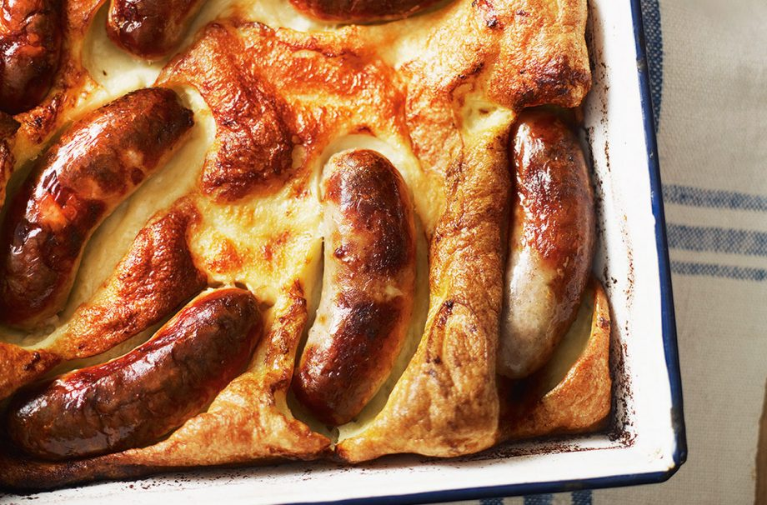jracfdwslaycrgwcrwn9

## Ingredients

• 30g (1oz) dripping or lard

• 454-500g packet good-quality pork and herb sausages

• 300ml (1/2 pint) milk

• 125g (4oz) plain flour

• 2 medium eggs

• Salt and pepper

• **For The Gravy:**

• 1 red onion, chopped

• 100ml beef stock, from a cube

• 2tbsp balsamic vinegar

• 1tsp cornflour, mixed with a little water

**Thank you to St Leonard’s Primary School for sharing with the St Aidan’s Community.**

# Toad in the hole recipe

## Method

Set the oven to fairly hot gas mark 6 or 200°C.

Place the dripping or lard in a smallish metal tin and place in the oven for 3-4 mins, or until melted. Add the sausages to the pan and turn to coat in the melted fat.

Bake, towards the top of the oven for 15-20 mins or until the sausages are an even golden colour.

While the sausages are cooking, prepare the batter. Pour the milk into the bowl of the food processor and add the flour, eggs and seasoning and whizz until blended. Add the finely chopped sage at this stage for a twist. Chill the batter until it’s needed.

When the sausages are browned pour over the batter – working quickly so as not to lose too much heat from the oven and immediately return the tin to the oven.

Bake for about 20-30 mins or until the batter has risen and is golden in colour and crisp. Serve immediately.

**For the gravy:**

Cook the red onion in the sausage fat from your cooking pan.

Once they are caramelised add the stock and balsamic vinegar to the cooked onions in the pan.

Bring to the boil.

Add the cornflour, mixed with a little water, to thicken.

Asda cornflour 250g 75p

Asda balsamic vinegar of Modena 250ml 71p

Asda 6 medium free range eggs 79p

Asda whole milk 1 pint 50p

Asda growers selection loose red onion 9p

Asda ground black pepper 25g 69p

Asda table salt 750g 27p

Richmond 8 thick pork sausages £1.50

Asda beef stock pots 4x24g 80p

Brittannia finest beef dripping 250g 70p

Total £7.25