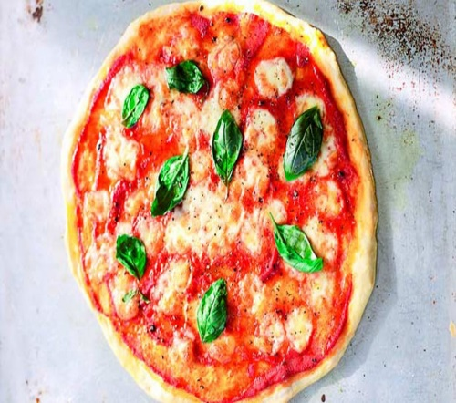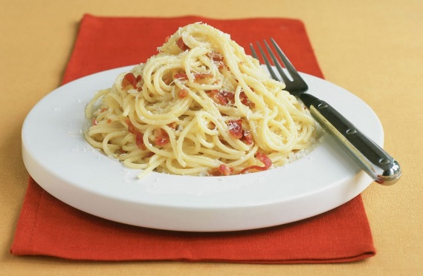jracfdwslaycrgwcrwn9

**Thank you to St Leonard’s Primary School for sharing with the St Aidan’s Community.**

This spaghetti carbonara recipe is a classic [Italian](https://www.goodtoknow.co.uk/recipes/tag/italian) dish, which makes for a brilliant mid-week [dinner](https://www.goodtoknow.co.uk/recipes/tag/dinner). It’s [quick and easy](https://www.goodtoknow.co.uk/recipes/tag/cheap-quick-easy) to make with egg, Parmesan and plenty of pancetta**.** This recipe serves two people and will take around 15-20 mins to prepare and cook. Try doubling the recipe to feed more people and make a [cheap mid-week meal](https://www.goodtoknow.co.uk/food/recipe-collections/cheap-family-meals-recipes-under-1-per-head-33813) for the whole family.

Asda olive oil 250ml £1.30

Asda 6 large free range eggs 95p

Asda grated parmesan cheese 25g £1.75

Asda growers selection garlic clove 50p

Asda diced pancetta twin pack 65g £1.30

Asda spaghetti 175g 53p

Total £6.33

## Ingredients

• 175g spaghetti or linguine

• 65g diced pancetta, or smoked streaky bacon, snipped

• 1 tsp olive oil

• 1 garlic clove, crushed

• 1 egg, plus 2 yolks

• 25g Parmesan, grated

## Method

Boil the pasta in a large pan of boiling salted water.

Add oil to a frying pan and fry pancetta for a few minutes until golden and crisp. Add garlic, fry for 1 minute, then turn off the heat.

Lightly whisk egg and yolks with most of the Parmesan and some salt and pepper (reserve a little to garnish).

Drain pasta, reserving a little of the cooking water.

Add eggs and 1 tbsp cooking water to the pasta, then mix until pasta is coated and creamy. Stir in the pancetta and garlic then serve, topped with the remaining Parmesan.