**Thank you to St Leonard’s Primary School for sharing with the St Aidan’s Community.**

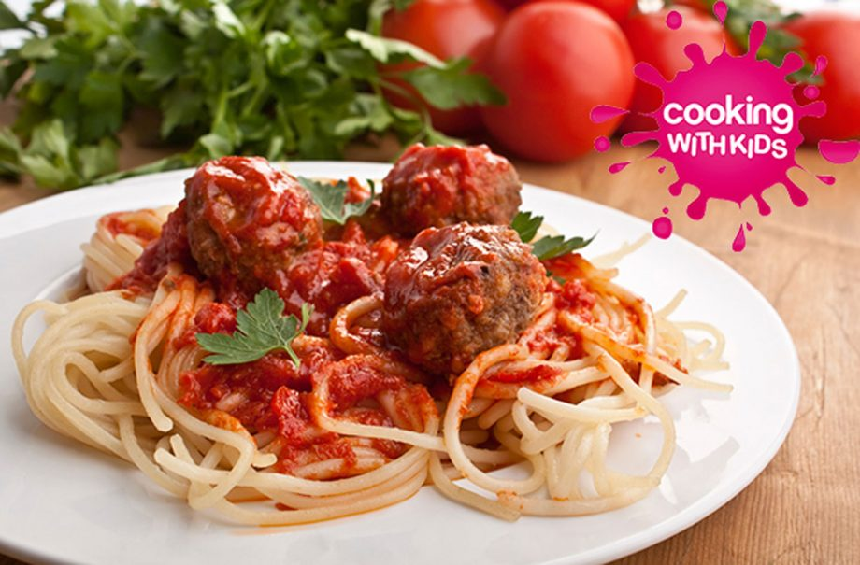jracfdwslaycrgwcrwn9

## Method

Add the oregano and basil to a clean bowl and add the mince. Squish the mince between your fingers mixing it with the herbs and divide into 16 portions. Roll into balls in your hands and then wash your hands clean.

Make the tomato sauce by frying the onion and garlic in the oil until soft. Add the meatballs and fry for a few minutes until browned on the outside. Add the tomato puree and tinned tomatoes, season and allow to simmer for 15 minutes on a low heat until the meatballs are cooked through. Meanwhile bring a saucepan of boiling water to a rapid boil and add the spaghetti. Cook until al dente and strain. Serve the meatball sauce with the spaghetti.

Tear the fresh herbs and sprinkle over everyone’s plate.

## Spaghetti and meatballs

## Ingredients

• 500g lean beef mince

• 1tsp dried oregano

• 1tsp dried basil

• 2 onions, finely chopped

• 2 garlic cloves, crushed

• 1tbsp olive oil

• 1 tin of chopped tomatoes

• 2tbsp tomato puree

• 500g spaghetti

• Handful of fresh basil or parsley

Asda butcher selection beef mince 500g £1.59

Asda growers selection loose onion x2 16p

Asda smart price chopped tomatoes 28p

Napolini olive oil 250ml £1.50

Asda tomato puree 200g 34p

Asda growers selection basil 50p

Asda growers selection garlic 50p

Asda dried basil 14g 59p

Asda dried oregano 12g 59p

Asda smart price spaghetti 20p

Total £6.25