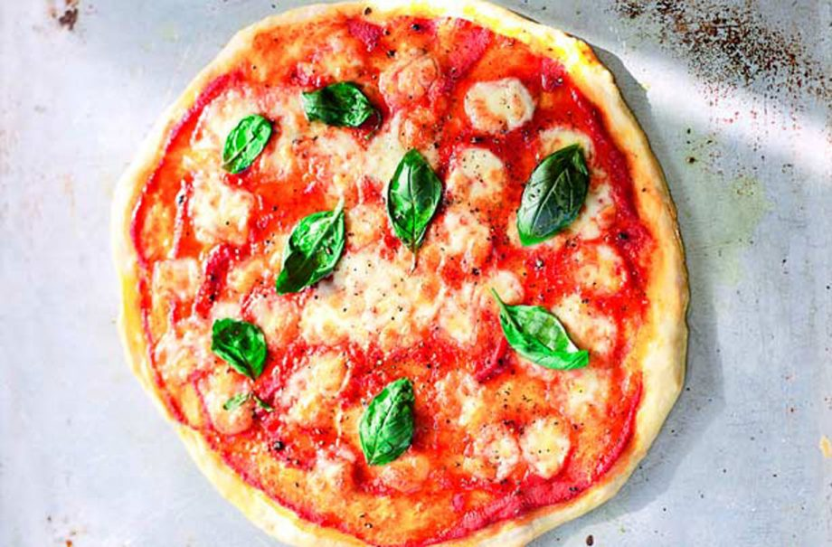jracfdwslaycrgwcrwn9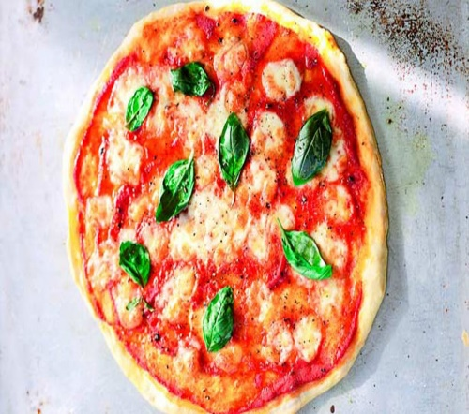

## Method

Prepare 2 baking trays by pouring 1 tablespoon of oil on each tray and spreading it with your fingers or pastry brush. Brush the inside of a large bowl with oil.

To prepare the dough, put the flour, yeast and salt into a large bowl, make a well in the centre and pour in the water with 1 tablespoon of oil. Use a wooden spoon to mix everything together to create a wet dough.

Turn out the dough onto a well-floured surface and work it with your hands for about 5 minutes until smooth and elastic. Place in the oiled bowl, brush the top with oil and cover with clingfilm. Leave to rest at room temperature for 25 minutes.

Preheat the oven to 200°C/400°F/Gas Mark 6.

Once rested, turn out the dough onto a well-floured surface and divide it into 2 equal halves. Use your hands to push each one out from the centre, to create 2 round discs about 25cm in diameter. Place the pizza bases on the oiled baking trays.

Spread the passata evenly over the top of the bases using the back of a tablespoon. Season with salt and pepper.

Divide the mozzarella between the 2 pizzas and drizzle each one with 2 tablespoons of extra virgin olive oil.

Cook in the middle of the oven for 18 minutes until golden brown. Two minutes before the end of the cooking, scatter over the basil and continue to cook. Serve hot and enjoy.

## Ingredients

• 200g strong white flour plus extra for dusting

• 7g fast-action dried yeast

• Pinch of salt

• 140ml water, warm

• 3 tablespoons extra virgin olive oil plus extra for brushing

• 200g passata (sieved tomatoes)

• 2 mozzarella balls, drained and cut into little cubes

• 4 tablespoons extra virgin olive oil

• 8 fresh basil leaves

• Salt and pepper to taste

**Thank you to St Leonard’s Primary School for sharing with the St Aidan’s Community.**

Gino D’Acampo’s classic margherita pizza recipe is so easy and is the perfect Friday night treat. This traditional Italian pizza is simple and delicious. This recipe makes 2 pizzas, perfect for sharing and will take 1hr and 15 mins to prepare and cook. It’s well worth the wait! This recipe shows you how to make a classic pizza base from scratch as well as a rich, tomato pizza sauce and how to top it perfectly too! If anyone knows Italian cooking, it’s Gino D’Acampo, so get the kids to help you make this classic margherita pizza.

Allison Dried Active Yeast 7g £1.00

Asda strong white bread flour 200g 60p

Asda extra virgin olive oil 250ml £1.35

Asda smart price tomato passata 200g 32p

Asda smart price mozzarella cheese balls x2 90p

Asda smart price still water 140ml 17p

Asda growers selection basil x4 £2.00

Asda ground black pepper 2g 69p

Asda table salt 4.36g 27p

Total £7.30