**Thank you to St Leonard’s Primary School for sharing with the St Aidan’s Community.**

With the launch of the FSM vouchers from the government we have put together a few ideas of what you could buy and make to feed your child for a week. Thank you to all the staff who contributed and I hope that this helps you plan your meals and be able to shop wisely using your vouchers. All of these meal ideas are things you can make with your child, so get them involved too!

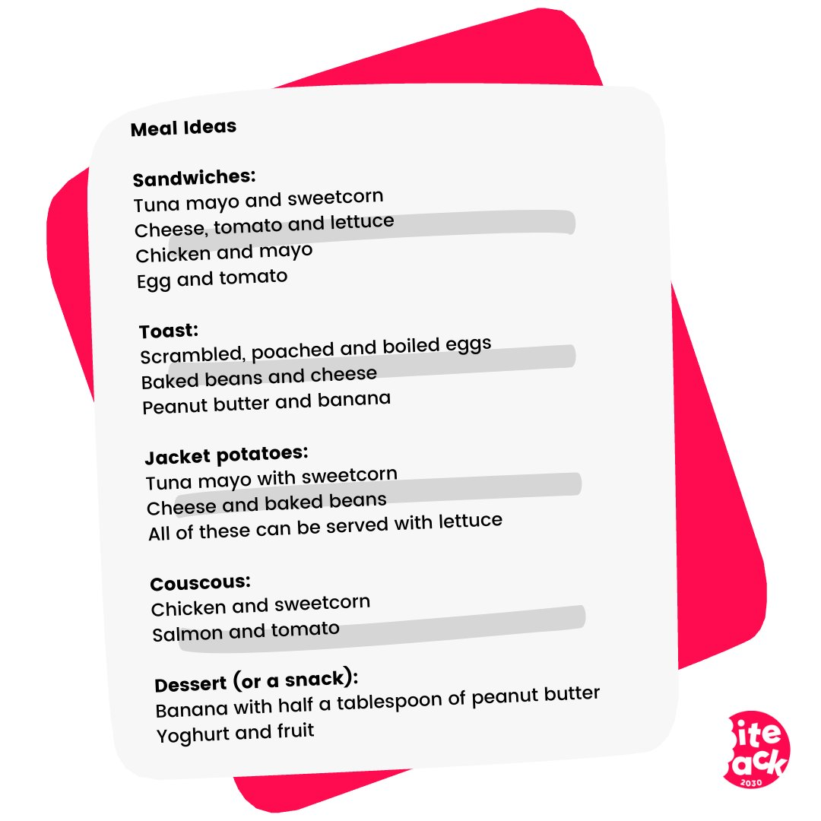

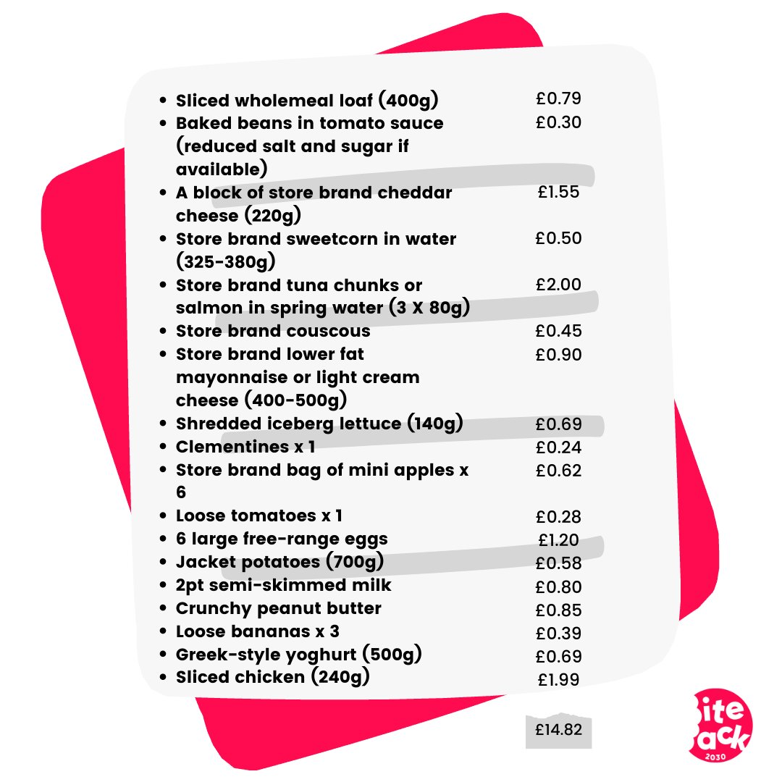***Thank you Miss Scothern & Twitter***

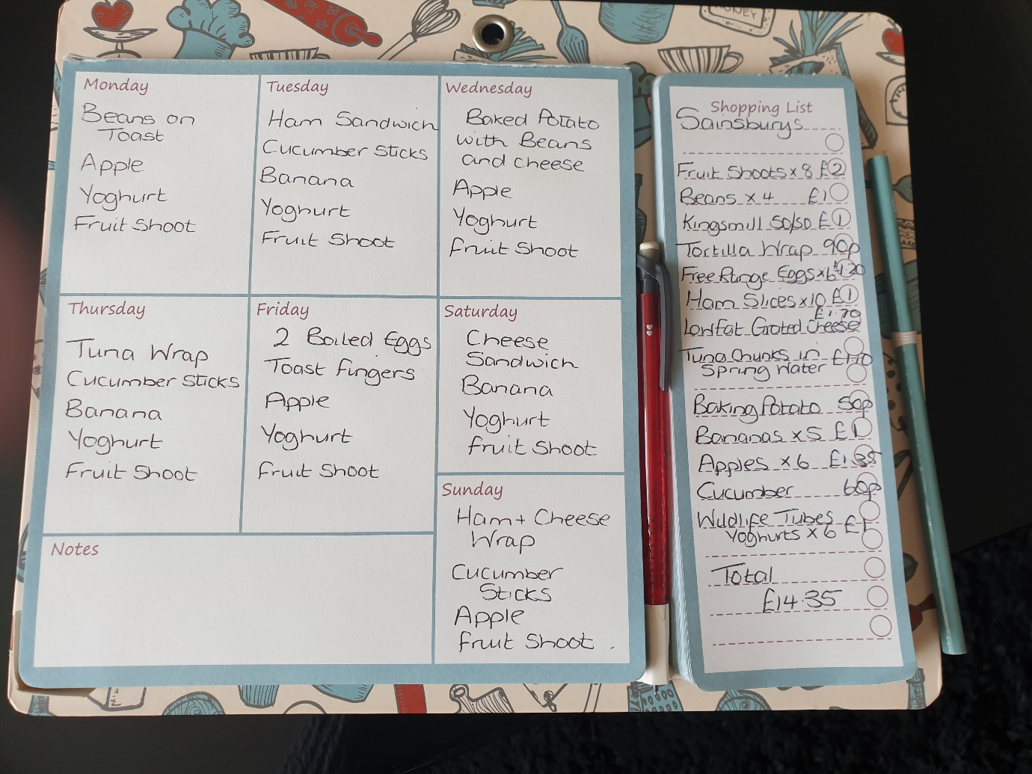

***Thank you Mrs Parkin***

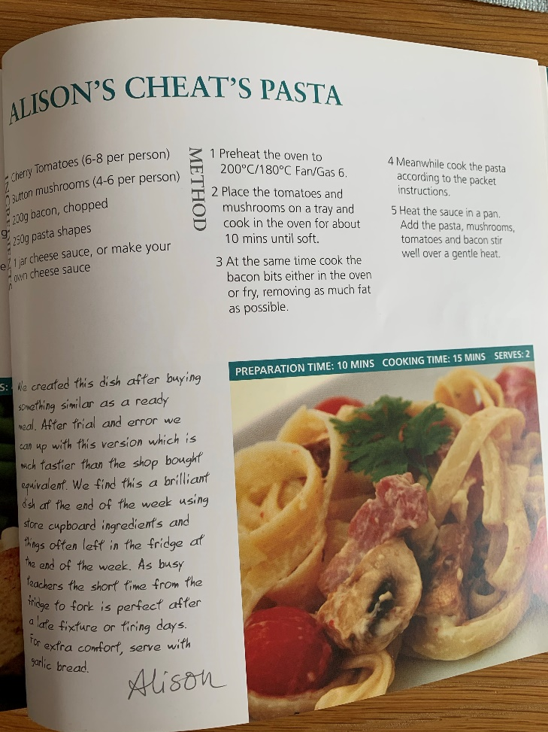 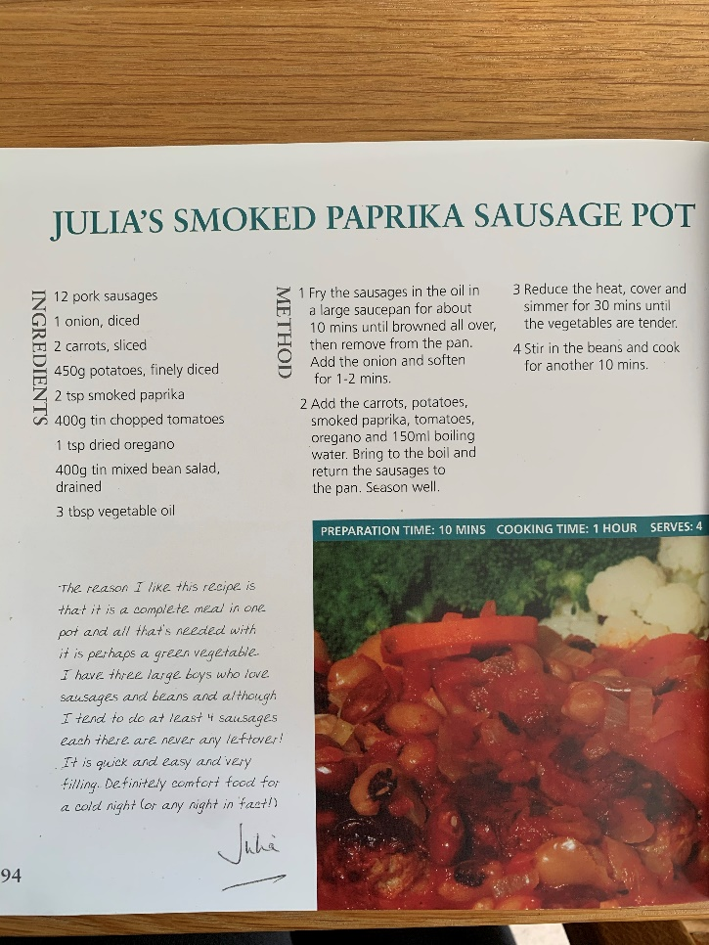

***Thank you Miss Scothern***

Make simple sandwiches, dessert, fruit and a drink

|  |  |
| --- | --- |
| **From ASDA**  50/50 bread = 95p  Cheese = £1.65  Ham = £1.25  frubes pouches X6 = £1.50  Apples X6 = £1.20  Raspberry butterfly cupcakes X6 = £2.50  Asda apple & blackcurrant drink X8 = £1.65  ***Total cost = £10.70*** | **From ASDA**  Flatbreads pk of 6 = 85p  Cheese grated X2 = £3.00  Tuna X3 = £2.50  Pesto red or green = 65p  Jar of sundried tomatoes = £1.00  Mayonnaise = £2.00  Bananas (garden gang) = 90p  Apples X6 = £1.20  ASDA cheeky monkeys crisps = 95p  Yollies X4 = £2.00  ***Total cost = £15.05*** |

***Thank you Mrs Bulmer***

|  |  |
| --- | --- |
| Bag of potatoes =£1.00  4X tin of beans = £2.00  Packet of cheese = £2.00  Loaf of bread = 80p  Sausage casserole sachet = £1.00  Bag of carrots = 50p  Bag of apples = £1.00  Bag of bananas = £1.00  6 eggs = £1.00  Bottle of orange/blackcurrant cordial = £1.00  Total cost = £14.30 | 5X meal ideas   1. Beans on toast 2. Jacket potatoes and beans 3. Sausage casserole 4. Cheese and ham toasties 5. Dippy eggs   All with some fruit and a drink |

***Thank you Mrs Smiles***

Recipes for Pizza, Spaghetti Carbonara, Winter Vegetable Soup, Toad in the hole and Spaghetti & Meatballs (see separate sheets)

***Thank you Mrs Heath***

**Chicken Burger**

The best things come in fours. There are four seasons, there were four Beatles, & there are four ingredients in this Fab Four Burger!

*Ingredients from Morrisons*

* 1 large free-range chicken breast fillet £2.95
* 2 eggs £1.35 (for 6)
* 100 g cornflakes £2.00
* 100 g breadcrumbs 80p
* 30 g Flora Buttery £2.50
* 1 romaine lettuce £1.00
* 2 tablespoons Hellmann's Real Mayonnaise £1.50
* 1 lime 30p per pack
* 2 bagel buns £1.50 per pack
* 2 grams salt 27p
* pepper 75p

***Total price: £14.92***

## Method

* 1 Slice the chicken breast; and season with salt and pepper.
* 2 Take two free-range eggs and whisk them in a small bowl. Remember eggs taste all the better if they’re from chickens who have lived rich and fulfilling lives.
* 3 Use whatever is to hand to finely crush the cornflakes- the end of a rolling pin in a bowl or the head of a spoon on a chopping board both work well.
* 4 Coat both chicken slices in the egg, then roll in the cornflakes until you have a nice crispy layer all over. After that, roll in the breadcrumbs and give them a little pat to make sure your mix has adhered properly.
* 5 Heat the Flora in a pan and then add your well-seasoned and perfectly-breaded chicken. Fry until golden brown on medium heat and you can stand the tantalising smell no longer.
* 6 Quickly mix the Hellmann's mayonnaise with the zest of lime and juice and spread the two bun halves for a scrumptiously zesty layer.
* 7 Finally, add a crisp leaf of romaine lettuce to either side of your chicken and sandwich between your mayonnaise-covered bun halves.

**Thank you Mrs Newton**

Enjoy making some delicious lunches and of course if you have any ideas, put them onto the twitter page or email them into school so that we can continue sharing.

We would love to see how you get on so remember to tweet those pictures of your delicious lunches.