**Thank you to St Leonard’s Primary School for sharing with the St Aidan’s Community.**

Happy Easter!

We hope you have a very happy Easter with your families.

We have some Holy Week/Easter themed ideas and some project ideas to keep your creative juices flowing over the Easter holidays:

1. **Ideas for Holy Week and Easter**

**Create a cross of hope**

Next week is Holy Week, it starts with Palm Sunday. It is tradition for Christians to display a palm cross in their homes. This year, that has become difficult so why not recreate your own cross from household items and post on twitter. This can be our cross of hope.

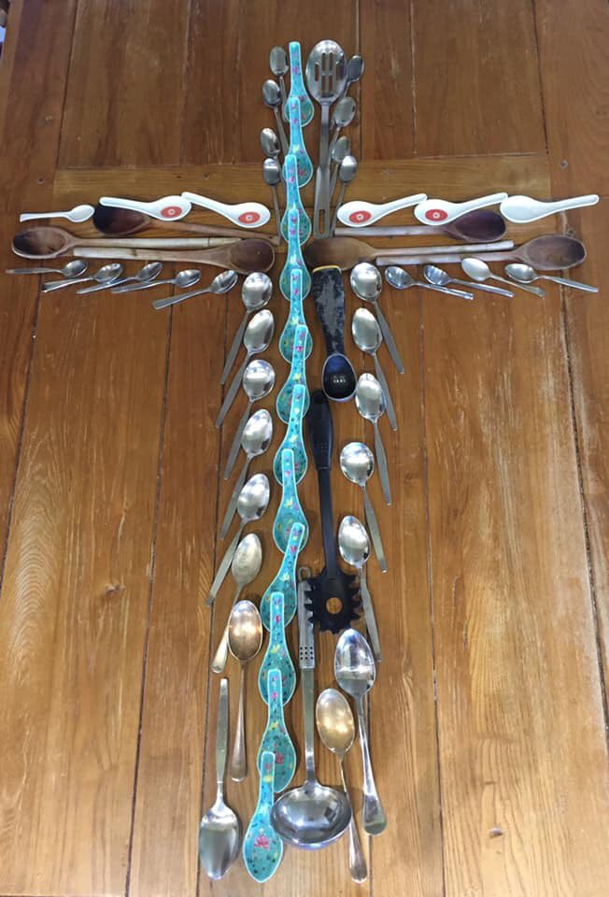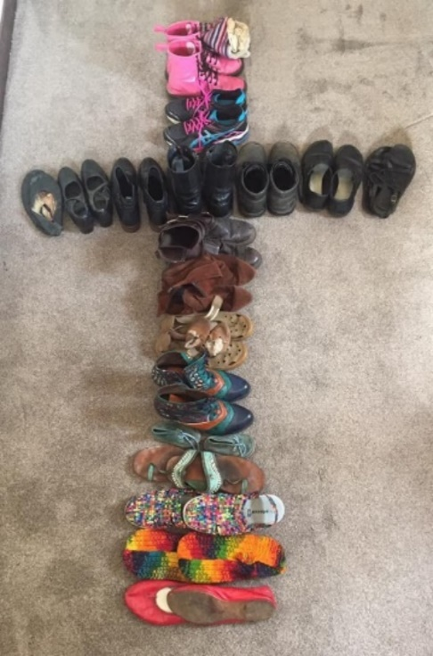

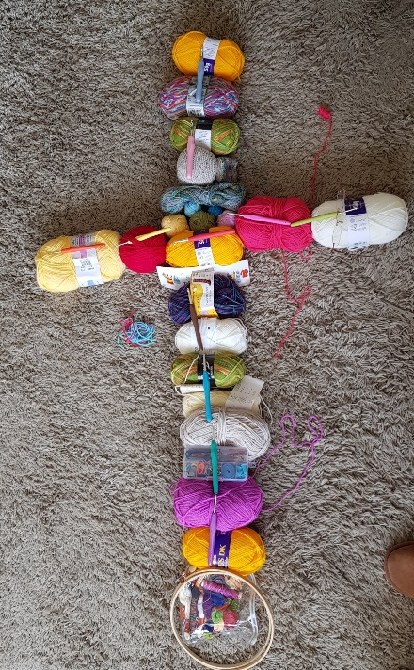

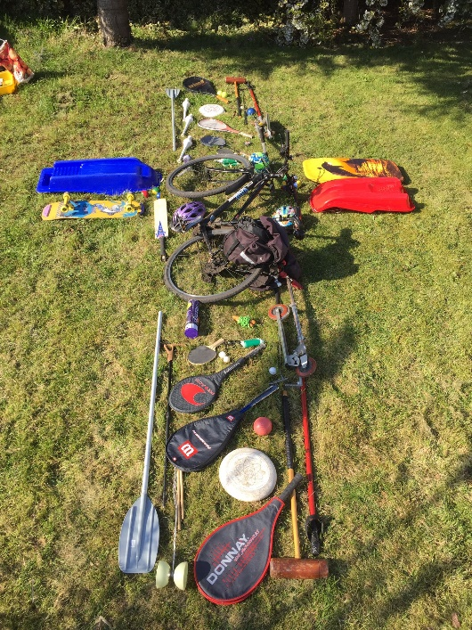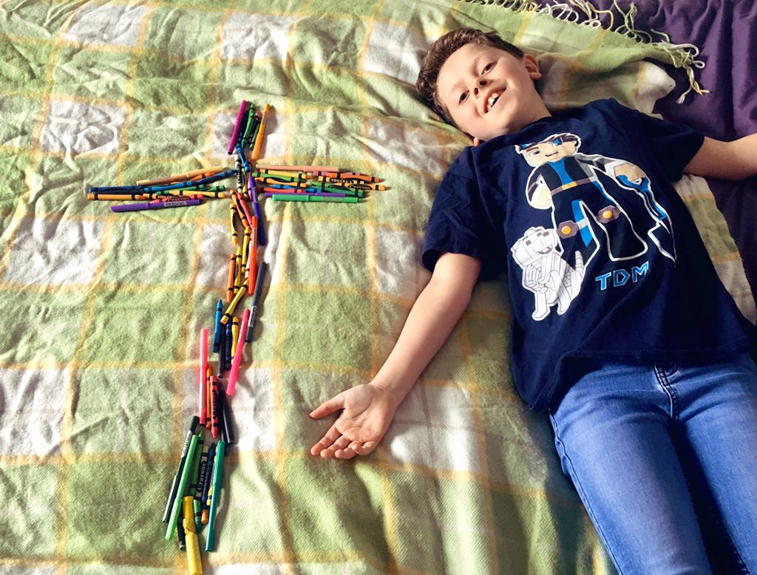

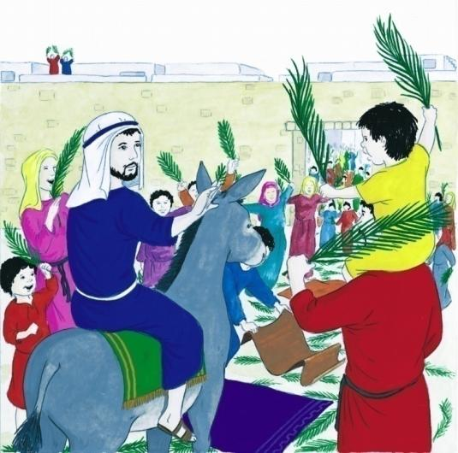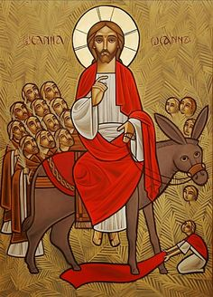**Retell the Easter story**

You could create a book or PowerPoint about Holy Week and Easter.

For our budding artists, you could recreate the Easter story through art and include a piece of for key moment.

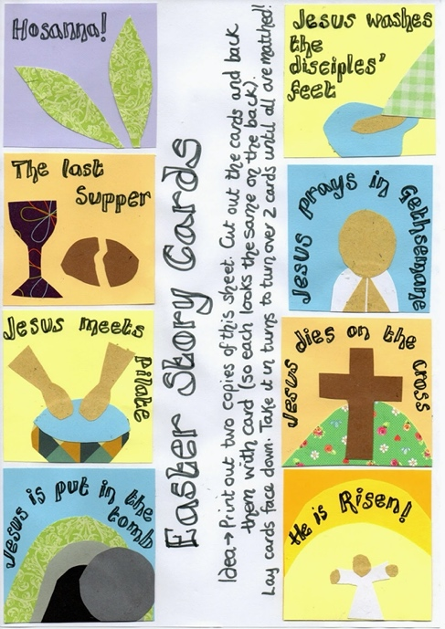

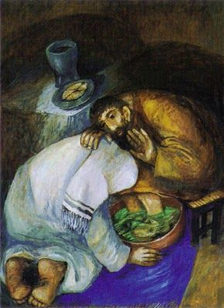



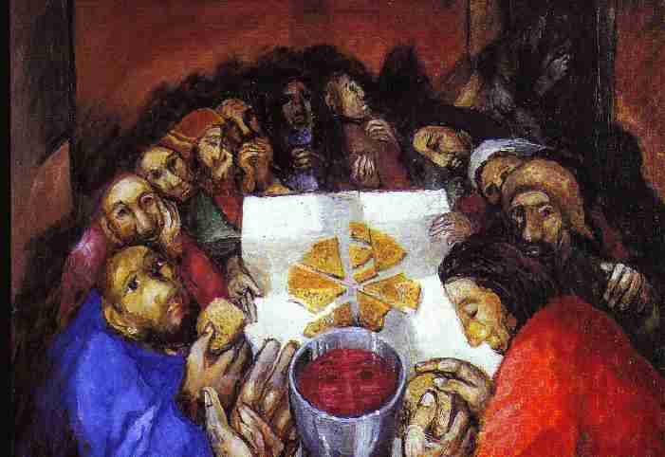



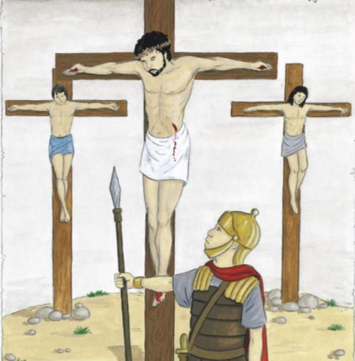

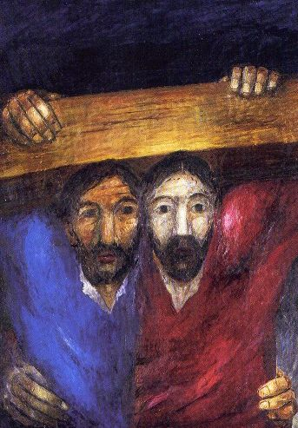

Here are some links about the Easter story to help you:

An animated story of Easter:

<https://www.bbc.co.uk/teach/class-clips-video/religious-studies-ks1-the-christian-story-of-easter/zhgv47h>

Christian celebrations on Good Friday and Easter Day

<https://www.bbc.co.uk/teach/class-clips-video/religious-studies-ks2-easter/znkngwx>

When is Easter:

<https://www.bbc.co.uk/teach/class-clips-video/religious-studies-ks2-easter/znkngwx>

Easter Story:

<https://www.bbc.co.uk/cbeebies/stories/lets-celebrate-easterperformance>

Audio stories about Easter:

<https://www.bbc.co.uk/teach/easter-collection/zf72rj6>

The Night Before Easter Story

<https://www.youtube.com/watch?v=1hnmkoLZLKo>

Retell Easter story using figures:

<https://www.pinterest.co.uk/pin/197595502379274568/>

And a story of the Easter Bunny:

<https://www.youtube.com/watch?v=xP__j1Fviaw>

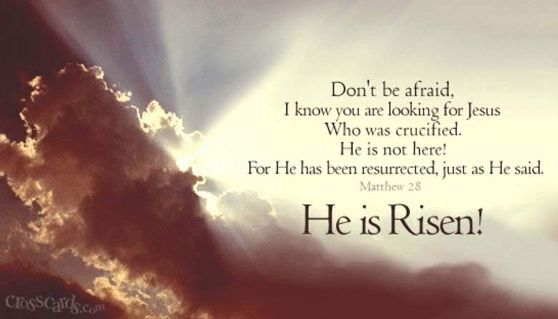**Create the Easter story through actions, scripture, music or dance**

Create a dance or freeze frame to represent each part of the story.

Decorate scripture references for each part of the story.

**Create an Easter prayer garden.**

There are lots of ways you can do this.

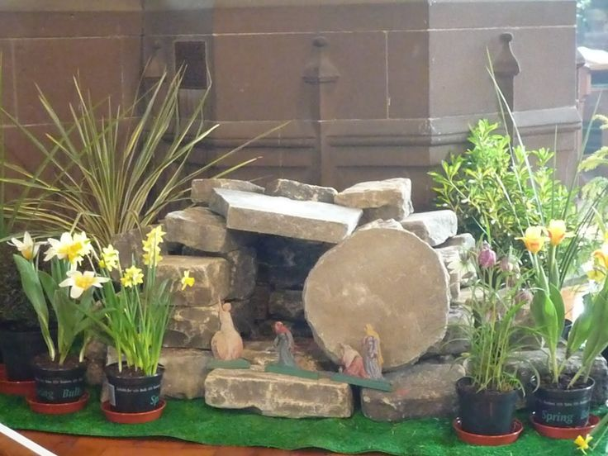You could create a model of a prayer garden or create a real area outside where you can pray. Your garden could change as we move through Holy Week from the sad and sombre Good Friday to the joy of Easter Sunday. Here are some ideas:

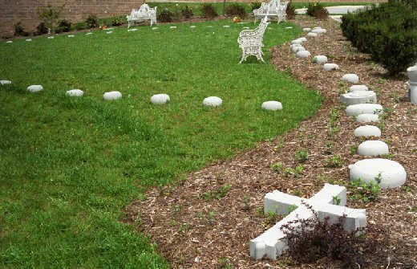

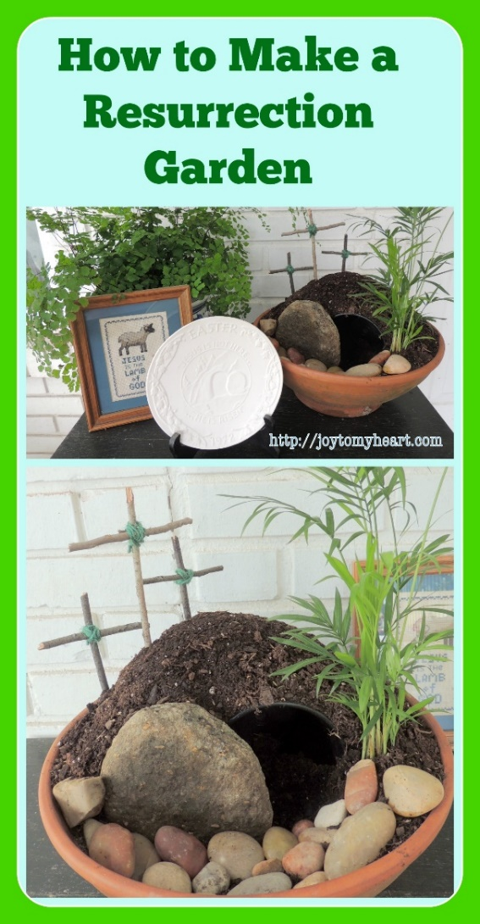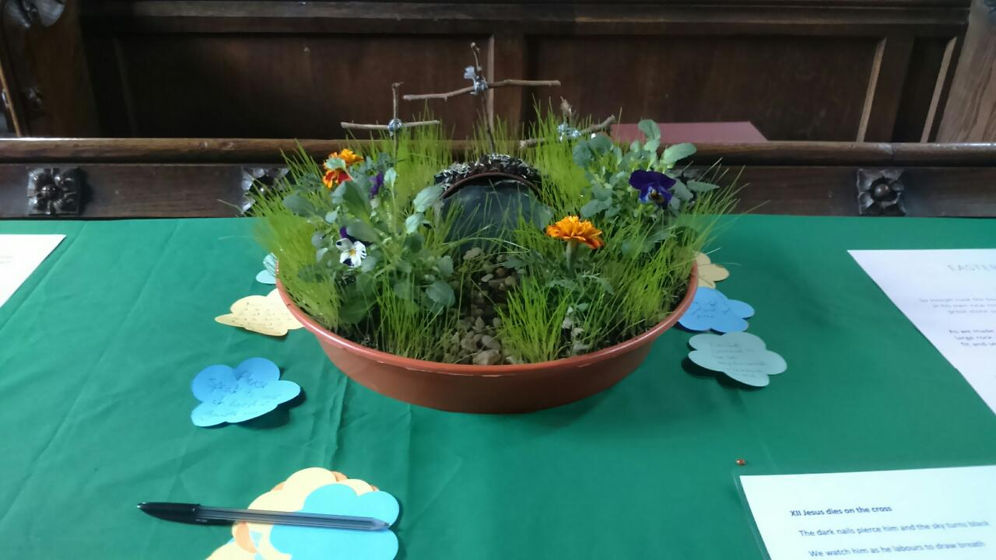

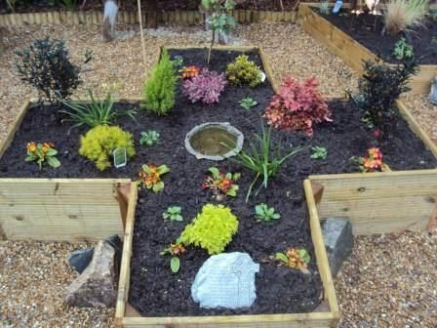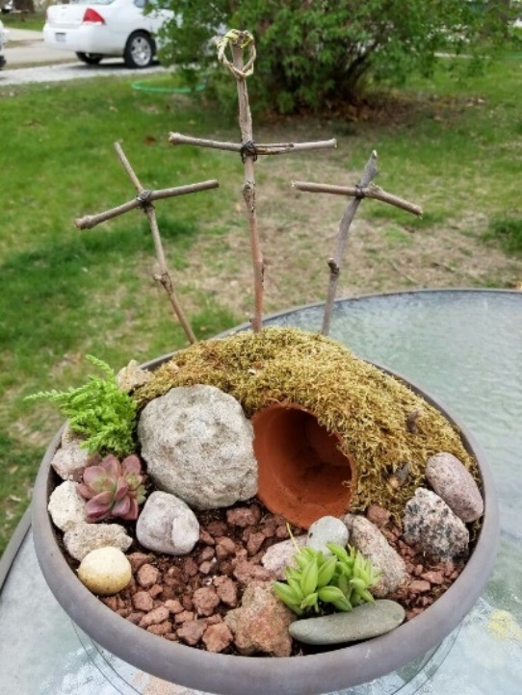

**Go on an Easter/Spring scavenger hunt:**

<https://teachingmama.org/wp-content/uploads/2019/04/spring-scavenger-hunt.pdf>

**Design an Easter egg with a geographical theme**

Travel the world. How is Easter celebrated in different parts of the world?

Research and present findings.

**Decorate a boiled or polystyrene egg. Tweet us your creations.**

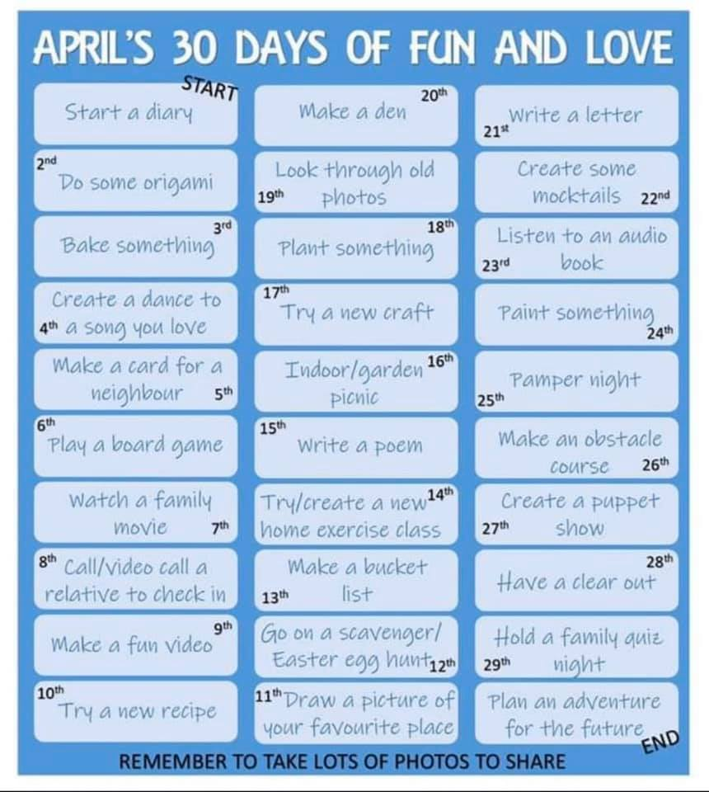**Try some of these April tasks…..**

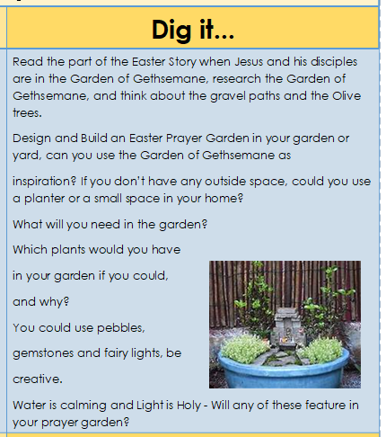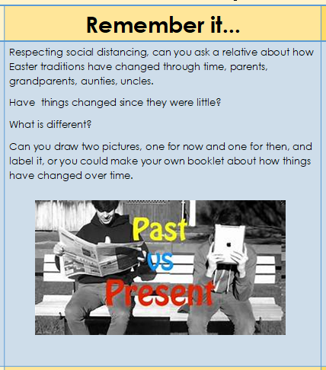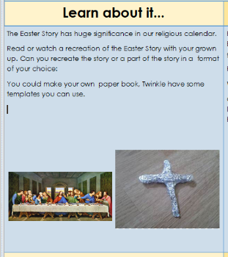Activities at a glance….

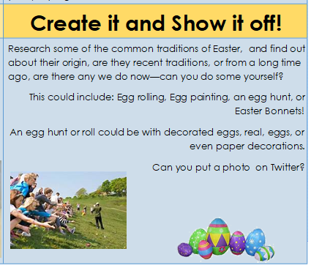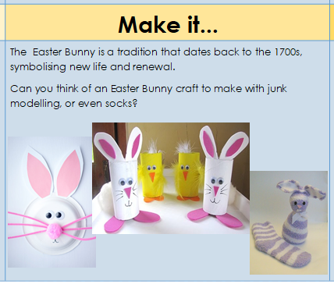

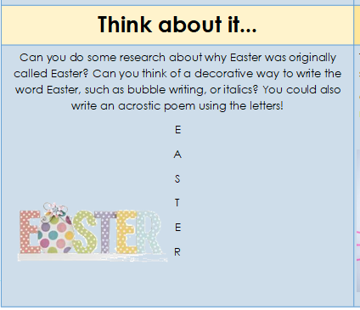

1. 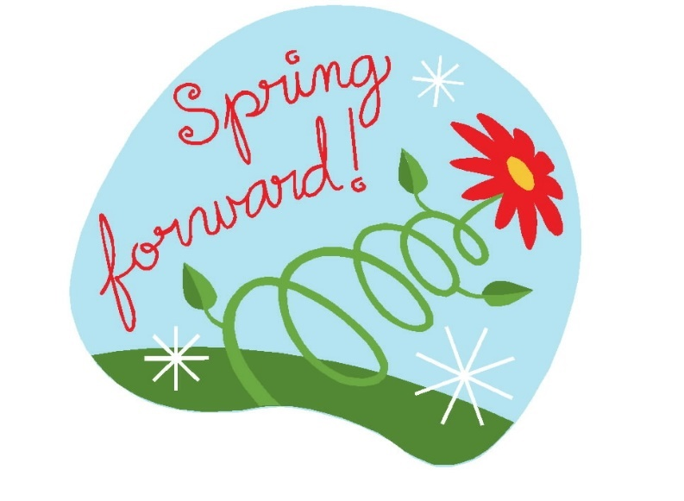**Spring forward project!**

Here are some ideas to help us to ‘Spring forward’ to a time when we are all back together again. Our time apart will become a huge part of history and will have changed the world forever. We need to think about how we want to remember this time and what we want to learn from it.

Here are some ‘Spring forward’ ideas:

Grow your own sunflower. Who can grow the tallest sunflower?

‘When this is all over’- Create a poster which shows the things that you will never again take for granted…… and what we want for the world.

Create a presentation about what you want people to learn from this time. Explain how we move forward and what you want people to learn or even change when our lives return to normal.

Interview someone talking about their feelings about what life is like right now.  This could be conducted with a family member or using an app such as WhatsApp or Skype.

Write a prayer for the future. Place the prayer within the image of a dove.

Write a food plan for the week. Imagine you had £30 to feed a family of 4. What would you buy?

Create a tree of thanks to all the people that are helping us. For e.g. The NHS, our families, supermarket workers etc…

Garden in a ..?.. – Find something that you can create a garden in.  These can be planted gardens or thought provoking gardens with the theme of Spring, new life, upcycling a household/personal object etc. 

**Create a Springtime piece of art.**

Research the artists below. Discover their techniques, what mediums they used as well as their lives and achievements.

Recreate your chosen ‘spring’ painting either in the style of the artist, or through other mediums- just be creative!

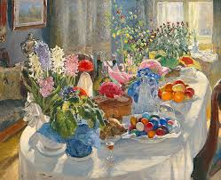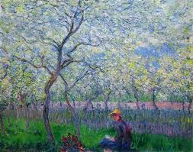

An Orchard in Spring – Claude Monet Aleksandr Vladimirovich Makorsky – Easter table.

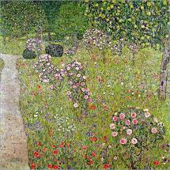

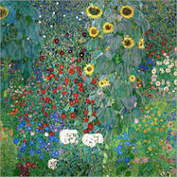

Farm garden with sunflowers – Gustav Klimt Orchard with roses – Gustav Klimt

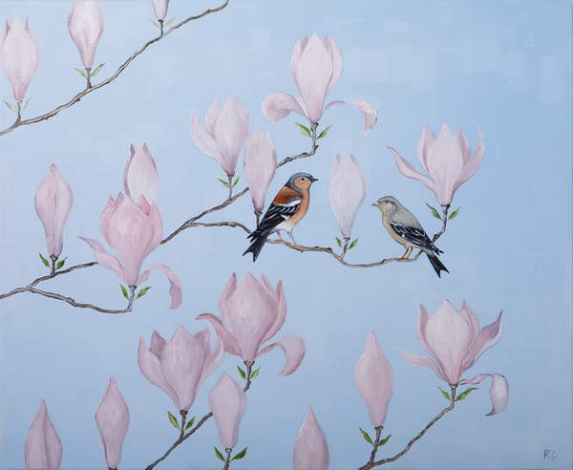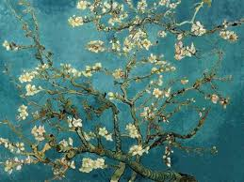

Almond Blossom – Vincent Van Gogh Spring at Last – Rebecca Campbell

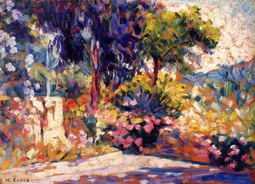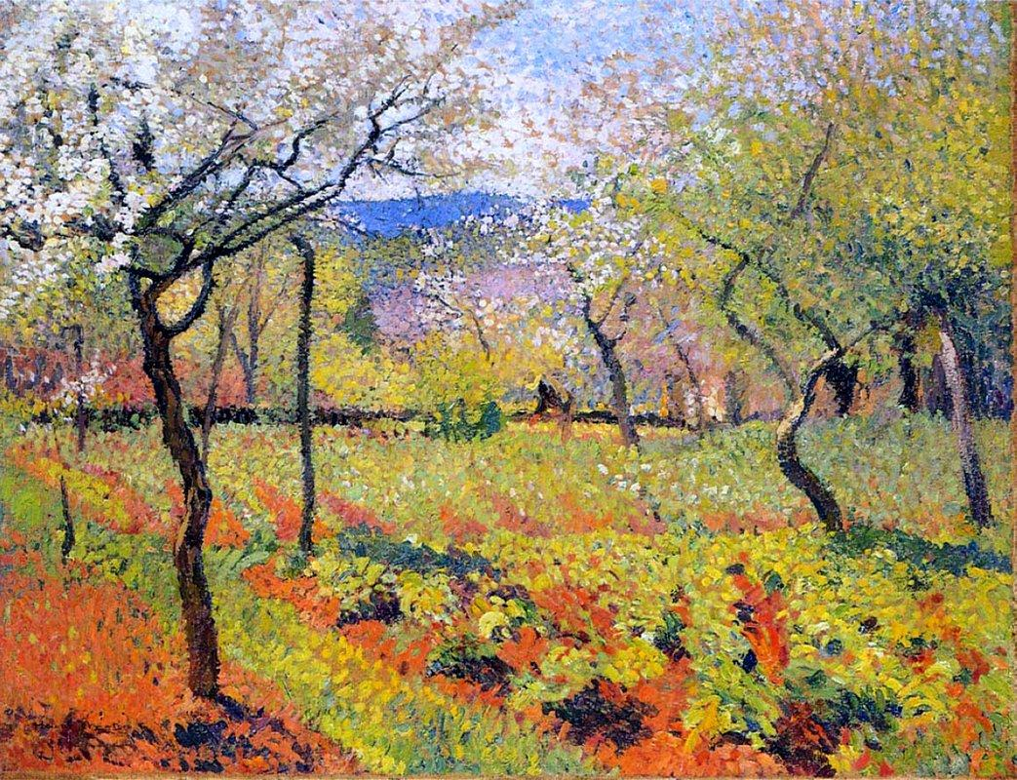

Flowering garden in Spring – Henri Martin The Flowered Trees – Henri Cross

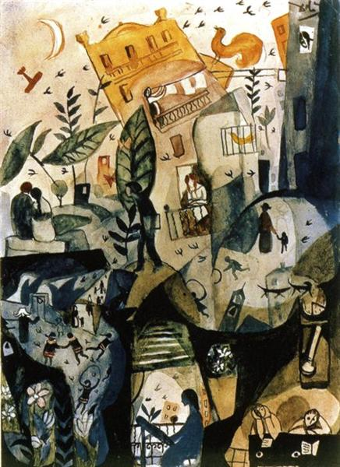

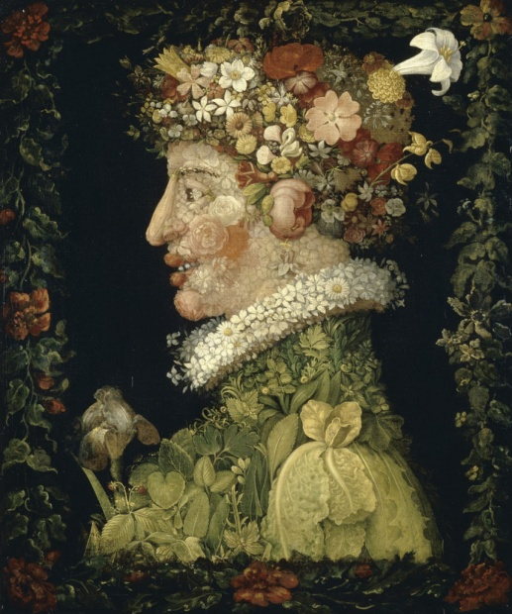

Giuseppe Arcimboldo, Spring, 1573 First Day of Spring – Salvador Dali

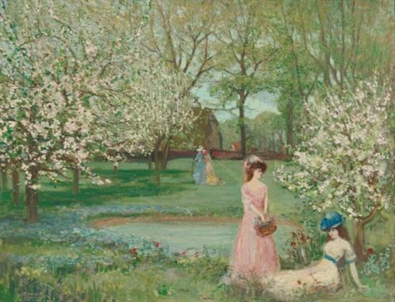

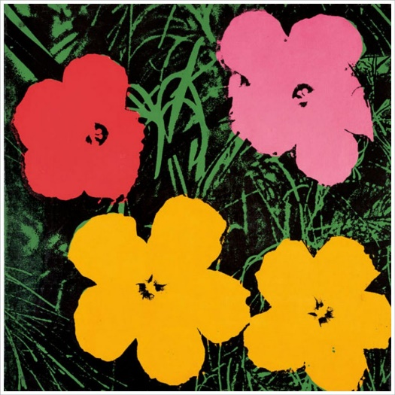

The Howe in Spring – Charles Conder Flowers – Andy Warhol

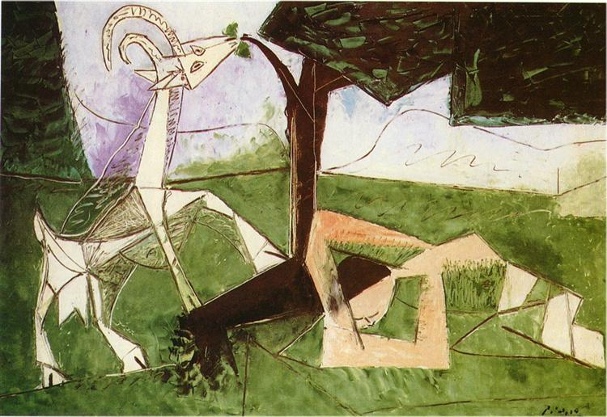

Spring – Pablo Picasso

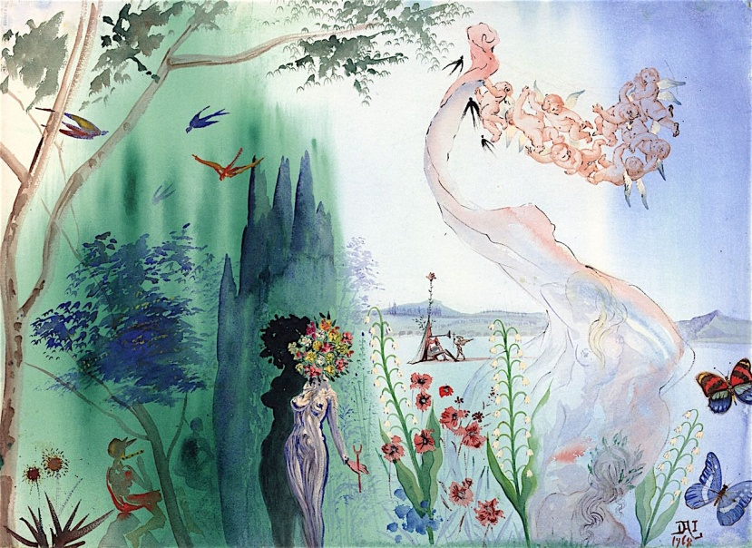

Spring – Salvador Dali

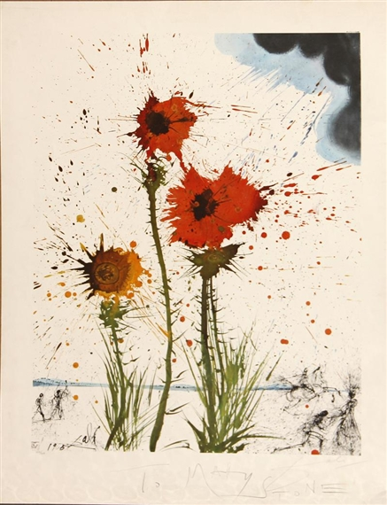

Spring Explosion – Salvador Dali